**Biology: 8. The Senses and Nervous System**

***Please remember to photocopy 4 pages onto one sheet by going A3→A4 and using back to back on the photocopier***

**Questions to make you think**

**Stereo Vision**

Roll a piece of paper into a tube. Hold it with one hand, say, the left hand, and look at a distant object through it with your left eye, keeping your right eye closed. Now, bring your right palm in front of your right eye so as to touch the tube, and then, open your right eye as well. You will see the distant object clearly through a hole in your right palm! (Both hands should be about 15-20 centimetres from your eyes). It’s fantastic, isn’t it? How do you explain it?

**The lens / Power of Accommodation**

Hold these notes out at arm’s length and notice that you can still read them clearly.

Now slowly bring the notes in until they are touching your nose. You can now no longer read them clearly.

Can you explain why?

**Optic Nerve / Blind Spot**

Close one eye and look at the cross with the open eye – can you still see the black dot “out of the corner of your eye”?

Now slowly move your head towards the cross. Notice that at one particular distance the black dot disappears out of the corner of your eye but then reappears as you move in closer still.   
Can you explain why?

**‘Adjusting’ you eyes to the brightness**

We are annoyed when cars coming from the opposite direction have their headlights on, because the bright light dazzles our eyes. Conversely when we enter a dark room for a while we are unable to see anything but then slowly our eyes get ‘adjusted’ and we are able to discern faintly the objects around us. Why do our eyes react to light the way they do? Hint: try the following activity.

Look into the eyes of another student beside you while the room is suddenly darkened – what do you notice about their ‘eyeballs’? The effect is even more impressive (for obvious reasons) is you go from dark to brightness. Can you explain why?

**Wearing goggle underwater helps you to see more clearly.**

Have you noticed that when swimming underwater, you can see much better if you wear goggles. Why?

**Upside-down glasses**

The lens in our eye inverts the image of the object we’re looking at so that the image which forms on the back of our eye (the retina) is actually inverted! So why doesn’t the world look upside down? What would happen if we wore a pair of glasses which made the image on the retina the right way up?

**Syllabus**

**OB28** Recall five sense organs in the human (eyes, ears, nose, skin, and tongue) and understand how these enable humans to gather information from their surroundings

**OB29** Describe the role of the central nervous system and the sensory and motor functions of nerves

**OB30** Locate the main parts of the eye on a model or diagram and describe the function of the cornea, iris, lens, pupil, retina, optic nerve and ciliary muscle

**Student Notes**

|  |  |
| --- | --- |
| **Sensory organ** | **Sense** |
| Eyes | Vision |
| Ears | Hearing |
| Nose | Smell |
| Skin | Touch |
| Tongue | Taste |

**Humans have five sense organs; eyes, ears, nose, skin and tongue**

**The central nervous system**

The central nervous system is composed of the brain plus the spinal cord.

Its function is to rapidly transmit messages to and from the brain to all other parts of body and to coordinate the body’s response.

The spinal cord carries signals to and from the brain in the form of electrical impulses.

**Sensory and motor nerves**

**Sensory nerves** carry signals ***from sensory organs towards the brain*** / central nervous system.

**Motor nerves** carry signals away ***from the brain / central nervous system to the muscles***.

**Communication between sense organ and brain**

1. The sensory organ (e.g. the eye) receives a stimulus (e.g. sunlight).
2. A message is sent from sense organ to brain or spinal cord via a sensory nerve.
3. The brain or spinal cord decides what to do (e.g. reduce size of iris) then sends a message along the motor nerves to the muscles and glands which cause them to respond.

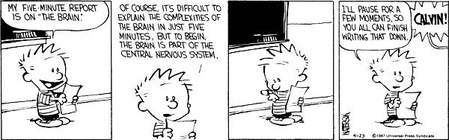

**The Eye**

**Be able to identify each of the following on a diagram and also know how to state their functions**

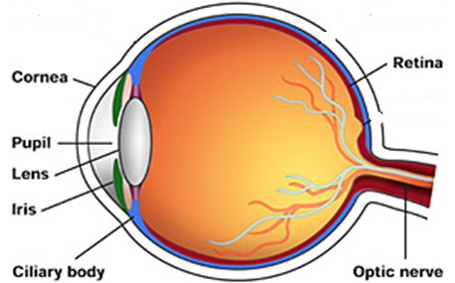



|  |  |
| --- | --- |
| **Part** | **Function** |
| Cornea | Allows light to pass into the eye |
| Iris | Controls the amount of light that enters the eye (it acts like a shutter) |
| Lens | Focuses light on the retina |
| Pupil | Opening through which light enters the back of the eye |
| Retina | Absorbs light and produces nerve impulses |
| Optic nerve | Carries messages from the eye to the brain |
| Ciliary muscle | Changes the shape of the lens when we look at near or far objects |

**Test yourself – can you identify each of the following parts of the eye?**

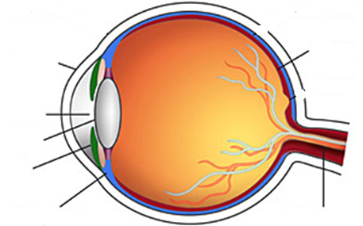

**Exam Questions**

1. [2007]

Nerves carry electrical messages around our bodies. Nerves have motor functions and sensory functions.

Explain the underlined terms.



1. [2007 OL]

Complete the following sentence.

The _________________ detects light.

1. [2007]

The diagram is of the human eye.

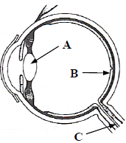Name the part labelled A.

1. [2011 OL]

The diagram shows the human eye.

1. Name the part labelled A.
2. At which of the points A, B or C does the image form?
3. [2011][2007]

What function has the ciliary muscle?

1. [2011]

What is the function of the cornea?

1. [2008 OL]

Examine the diagram and answer the questions that follow.

1. Identify the part labelled A.
2. Identify the part labelled B.
3. What is the function of the part labelled A?
4. [2008]

Give the function of the iris.

1. [2008][2008 OL]

Give the function of the pupil.

1. [2008]

The pupil is transparent.

Why does the pupil appear to be black in most situations?

1. [2009 OL]

What is the name of an organ which detects light?

What is the name of an organ which detects sound?

**Questions to make you think**

**Stereo Vision**

Your brain receives two separate images from your eyes and combines them. Usually the images are similar so you don’t notice any discrepancies.

**The lens / Power of Accommodation**

For objects which are approximately 6 m or closer to your face, the lens in your eye has to change shape to allow the light rays to intersect on your retina…it accommodates to give a clear image.

The lens in your eye cannot curve sufficiently to enable the rays of light to intersect on your retina.

For objects greater than 6 m from your face the rays of light are travelling roughly parallel so the shape of the lens remains roughly constant.

**Optic Nerve / Blind Spot**

This is because at that one specific position light from the black dot was falling on the opening to your optic nerve and there is no retina there so no light receptors. For this reason it is known as your blind spot.

**Adjusting’ you eyes to the brightness**

Your iris acts like a pair of shutters which close together when too much light gets through and opens up when there is very little light in the background to enable more light to get through. If too much light gets through it seems to ‘drown’ the receptors and we interpret this as pain (our eyes are ‘dazzled’).

**Wearing goggle underwater helps you to see more clearly.**

Light refracts when travelling from air through the cornea of your eye, but water and the cornea have the same refractive index (not surprising I suppose – the cornea seems to be mostly water) so light which travels from water to your cornea doesn’t refract much at all, so there is no focusing on the retina.

By wearing goggles however light which hits your eye is coming from air, so the usual focusing applies and objects appear normal. Unless you happen to be on a family holiday in Majorca and find yourself underwater staring at Granny’s cellulite arse, in which case ‘normal’ is not the word which first comes to mind.

By the way, this concept was asked in 2008, Question 8 (no reference to Granny unfortunately).

**Upside down glasses**

The brain realises that the image on the retina is upside-down so takes this into account when ‘forming’ the final image.

The upside-down glasses were first investigated by George Stratton in the 1890’s. Since the image that the retina of our eye sees is inverted, he wanted to explore the effect of presenting to the retina an upright image. He reported several experiments with a lens system that inverted images both vertically and horizontally. He initially wore the glasses over both eyes but found it too stressful, so he decided to wear a special reversing telescope over one eye and keep the other one covered.

In his first experiment, he wore the reversing telescope for twenty-one hours. However his world only occasionally looked normal so he ran another experiment where he wore it for eight days in a row. On the fourth day, things seemed to be upright rather than inverted. On the fifth day, he was able to walk around his house fairly normally but he found that if he looked at objects very carefully, they again seemed to be inverted. On the whole, Stratton reported that his environment never really felt normal especially his body parts, although it was difficult to describe exactly how he felt. He also found that after removing the reversing lenses, it took several hours for his vision to return to normal.

**Exam Solutions**

1. Motor function: to carry messages from the brain/ spinal cord/ central nervous system to muscles.

Sensory function: to carry messages to the brain/ spinal cord/ central nervous system from sensory organs.

1. Eye
2. The lens
3. A: lens
4. B
5. It controls/ changes the shape of the lens.
6. Cornea: allows light into the eye/ transparent/ refracts light/ focuses light/ protection
7. Retina
8. Lens
9. Allows light in
10. The iris controls the amount of light entering the eye
11. The pupil allows light to enter the eye
12. Light absorbed/ no light reflected out
13. Light: eye, Sound: ear

**Other Test Questions**

1. Name the five sense organs and state what stimulus each sense organ responds to (e.g. “the eye responds to sight”).
2. The central nervous system consists of the __________________ and the ________________.
3. What is the function of the central nervous system?
4. Draw a diagram of the eye and include each of the following: the cornea, iris, lens, pupil, retina, optic nerve and ciliary muscle.
5. Give the function of each of the parts named above using the table below:

|  |  |
| --- | --- |
| **Eye part** | **Function** |
| The cornea |  |
| The iris |  |
| The lens |  |
| The pupil |  |
| The retina |  |
| The optic nerve |  |
| The ciliary muscle |  |